Class - 3

Callback function

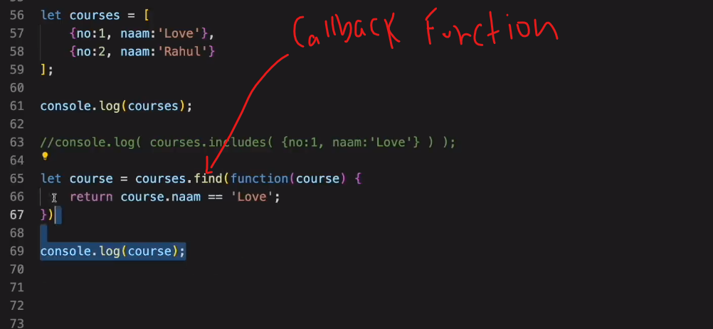

Html code :

<!DOCTYPE html>

<html lang="en">

<head>

    <meta charset="UTF-8">

    <meta name="viewport" content="width=device-width, initial-scale=1.0">

    <title>Document</title>

</head>

<body>

    <script src="/fun1/index.js"></script>

</body>

</html>

JavaScript code :

//callback function objct mai search karna

let city=[

    {no:1,name:'mumbai'},

    {no:2,name:'kerla'},

    {no:3,name:'goa'}

];

let cityData=city.find(function(cities){

    return cities.name=='kerla';

});

console.log(cityData);

output :

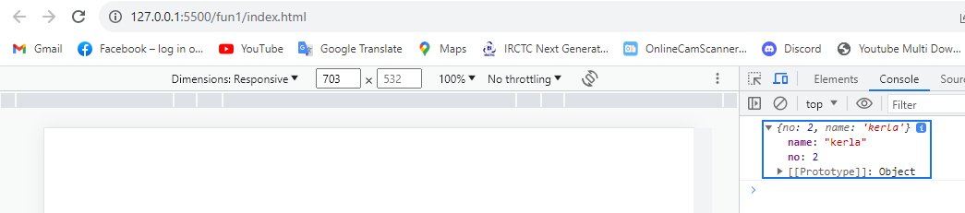

Arrow function

//callback function objct mai search karna

let city=[

    {no:1,name:'mumbai'},

    {no:2,name:'kerla'},

    {no:3,name:'goa'}

];

let cityData=city.find(function(cities){

    return cities.name=='kerla';

});

console.log(cityData);

//using arrow function

let cityData2=city.find(cities=>

     cities.name=='mumbai'

);

console.log(cityData2);

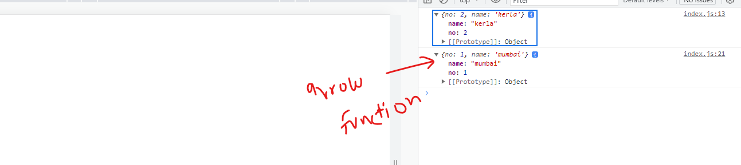

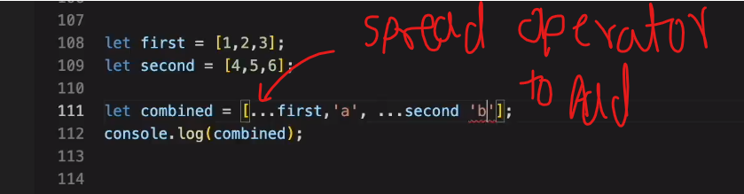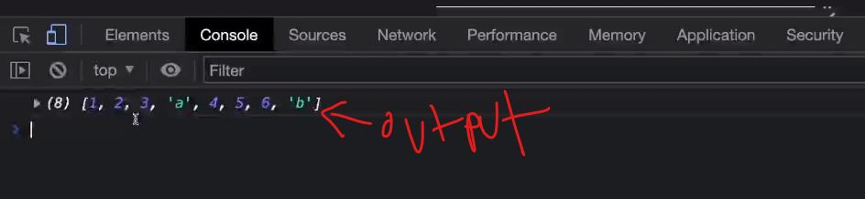

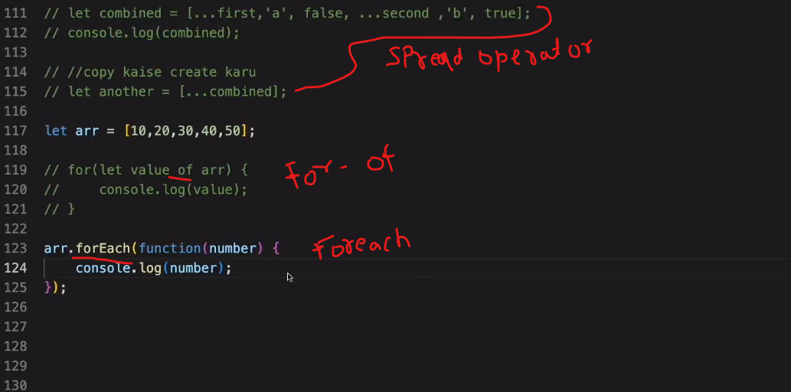

Using foreach

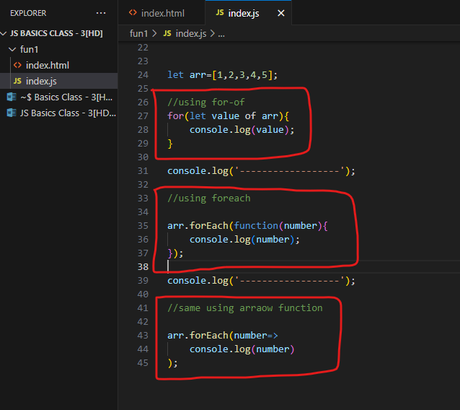

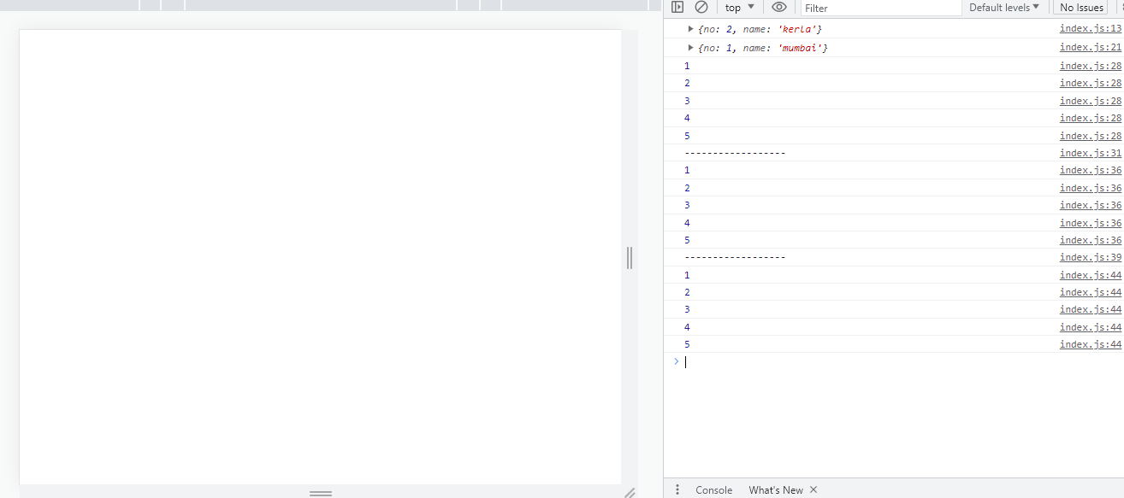

Array join

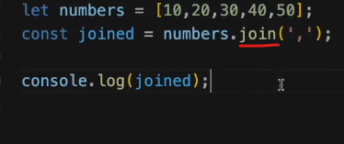

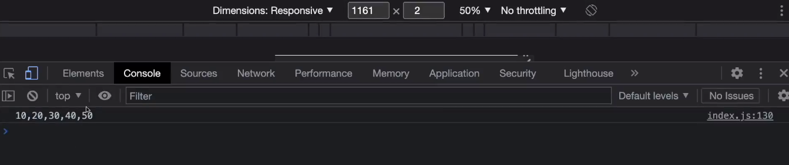

Split: split wala method ek array create kar deta hai

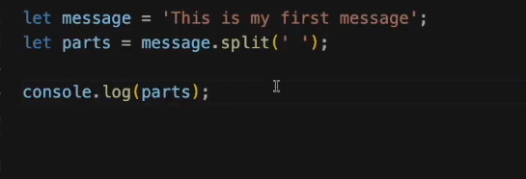

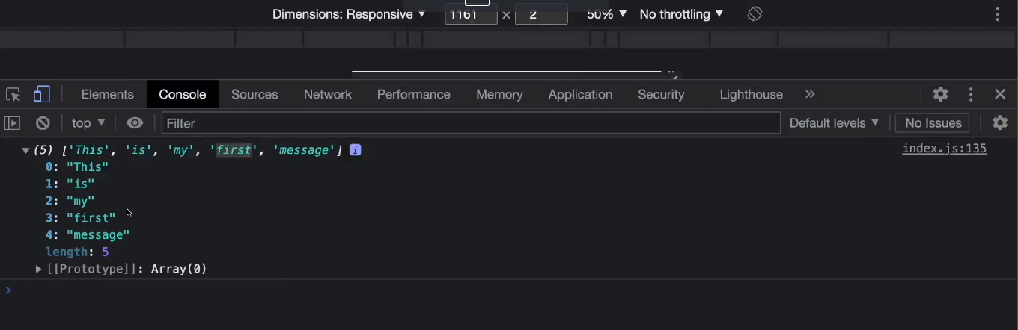

Sort

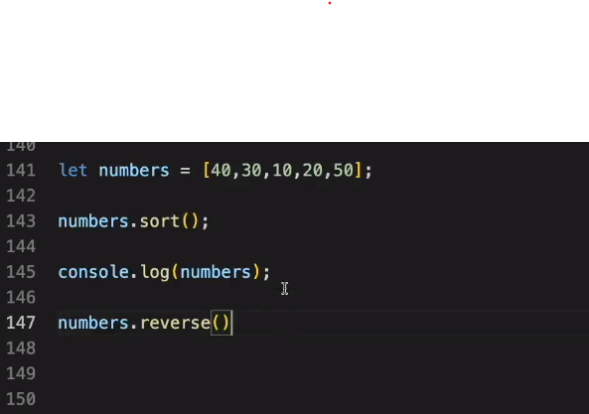

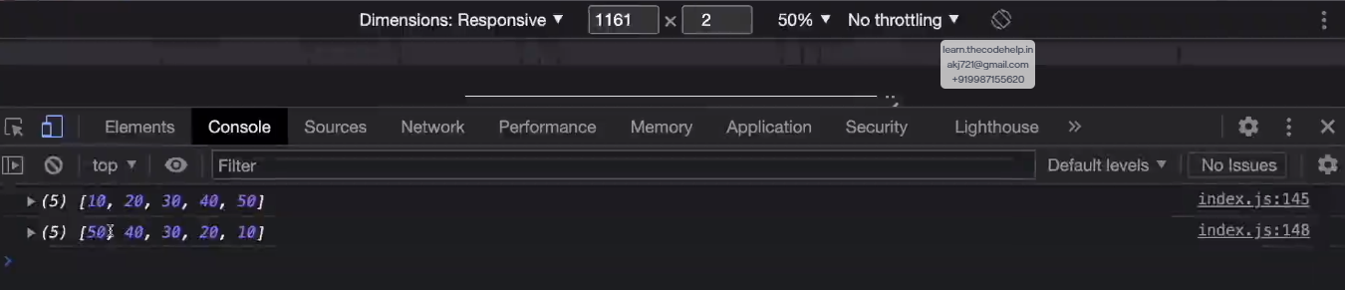

Filter

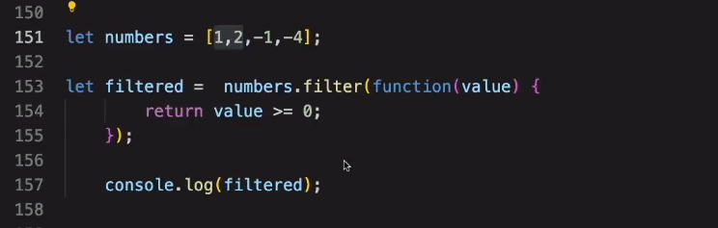

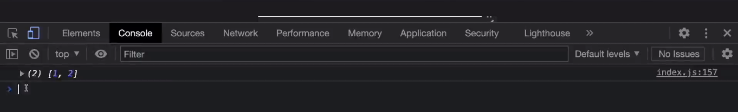

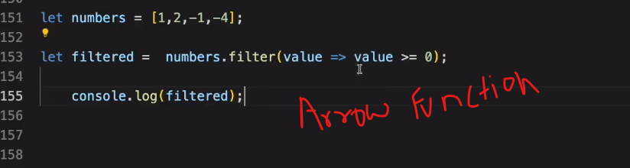

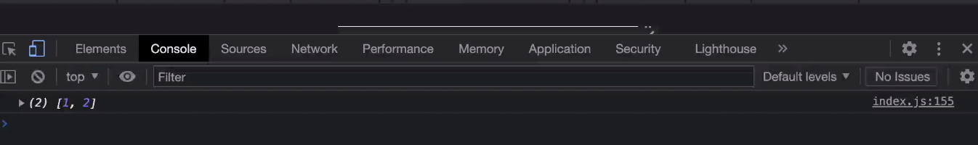

Mapping array

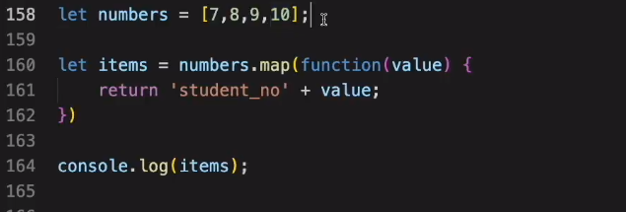

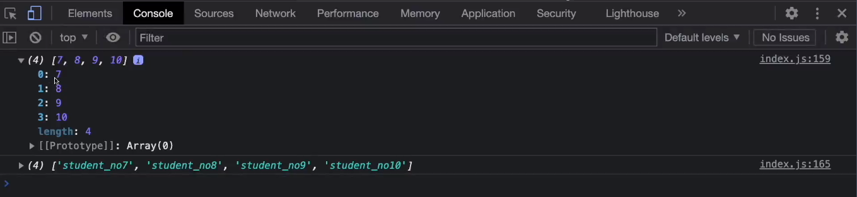

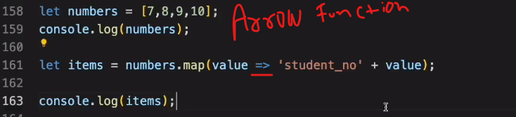

//using mapping

let numbers=[2,1,-9,3,-7];

let filteres1=numbers.filter(value=>value>=0);

console.log(filteres1);

console.log('-----------------------');

let map1=filteres1.map(function(val){

    return {id:val};

});

console.log(map1);

console.log('-----------------------');

let map2=filteres1.map(val2=> {id:val2} );

console.log(map2);

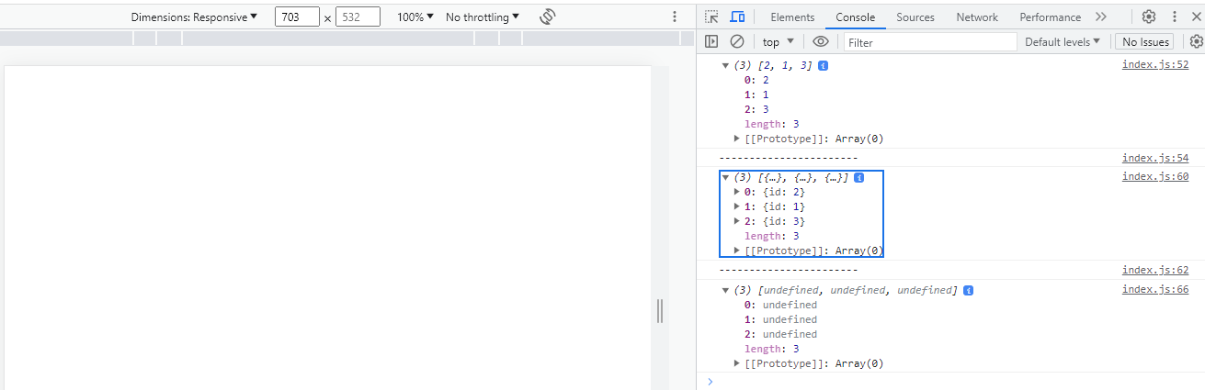

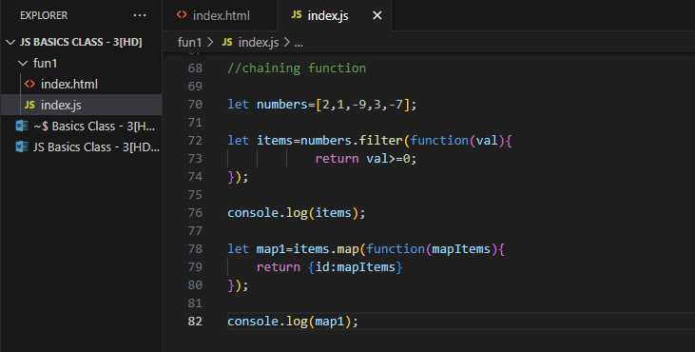

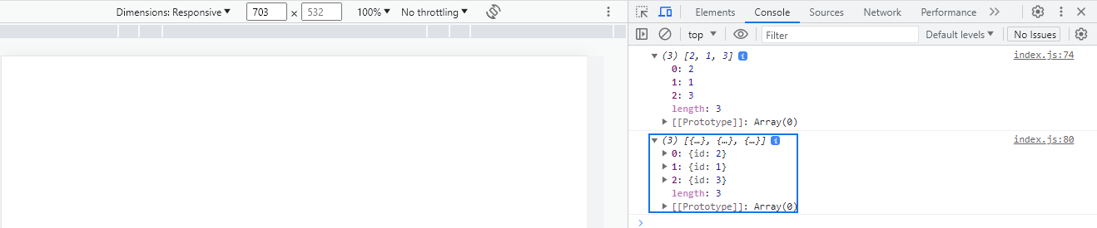

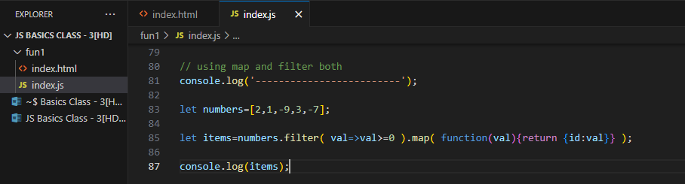

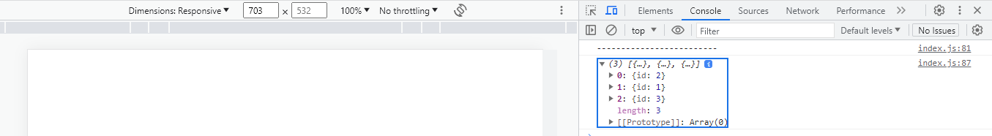

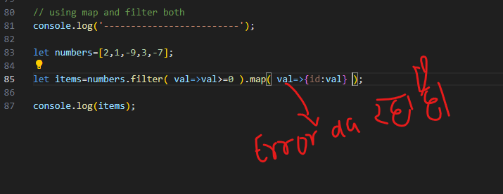

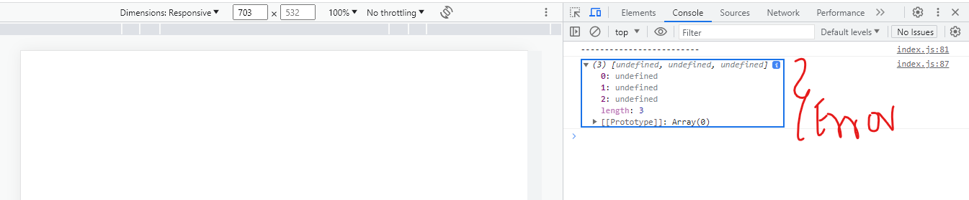

Class – 4